½ page summary for Pebble Pad:
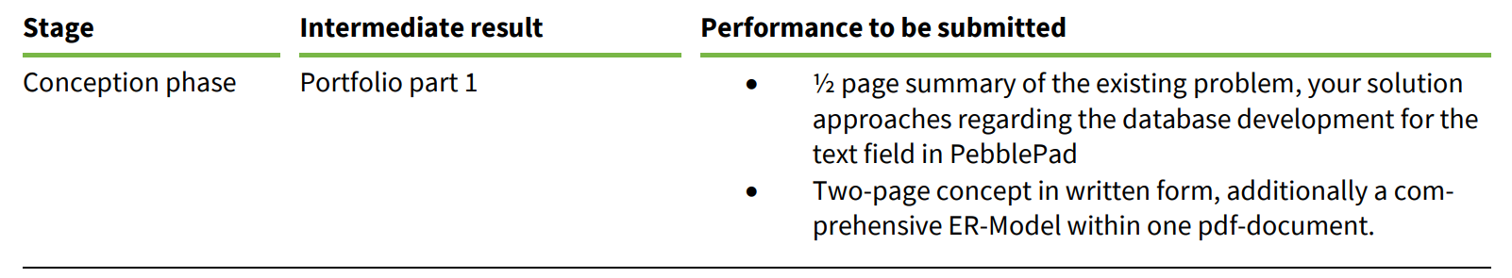
Summary of Phase One: Database Design for Airbnb Datamart
In the first phase of this project, the primary goal was to design a database for an Airbnb-like platform that could handle the complex relationships between guests, hosts, vacation rentals, and bookings. The challenge was to ensure that the database would be well-organized, consistent, and scalable for future growth.
To achieve this, an Enhanced Entity-Relationship Diagram (EER) was created using MySQL Workbench. The EER includes 25 entities that cover all the key aspects of the system. Triple relationships were included to manage complex data interactions, and recursive relationships were added where needed. Chen notation was used to define the cardinality of these relationships, which helped to clarify the connections between entities. Additionally, a data dictionary was developed to document the attributes of each entity, including their data types and how they fit into the overall database structure.

